Project Design Phase-I
Solution Architecture

Date | 1 November 2026
Team ID | EN25CS3010155
Project Name | Global Fuel Prices and Taxation Trends: A Comprehensive Global Performance Intelligence Report
Maximum Marks | 4 Marks

Solution Architecture:
Solution architecture is a complex process – with many sub-processes – that bridges the gap between business problems and technology solutions. Its goals are to:
- Find the best tech solution to solve existing business problems.
- Describe the structure, characteristics, behavior, and other aspects of the software to project stakeholders.
- Define features, development phases, and solution requirements.
- Provide specifications according to which the solution is defined, managed, and delivered.

Sample Solution Architecture Diagram:
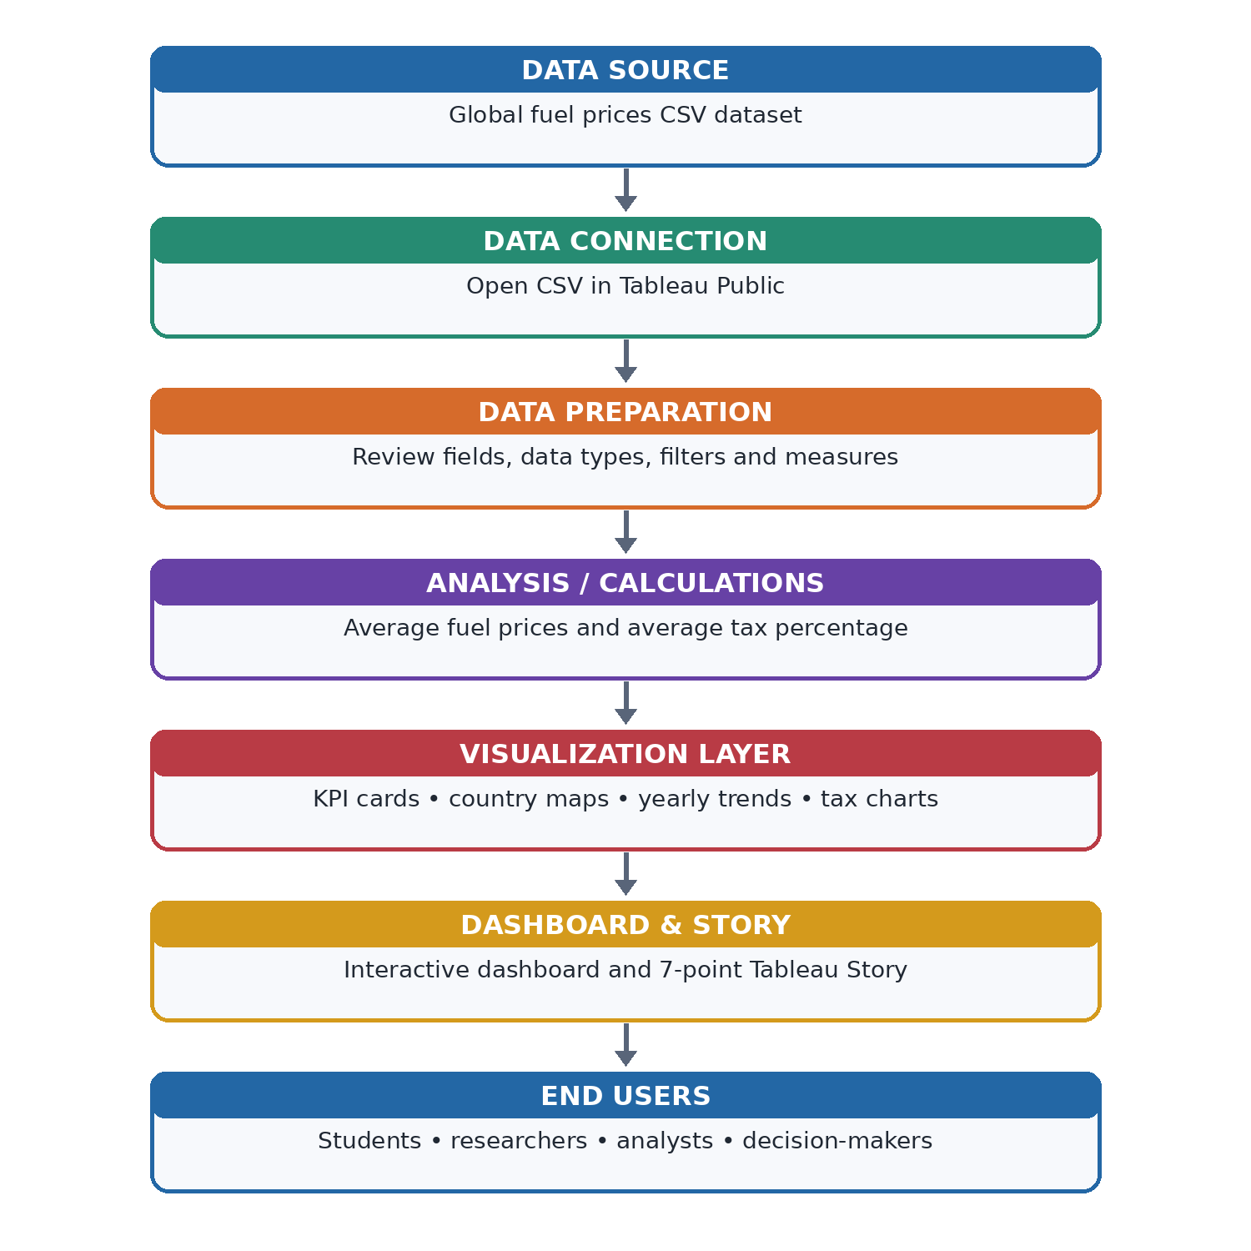

Component Description Table
Component Name | Description / Role in Architecture | Technology Used
CSV Dataset | Provides country, region, year and fuel-price/tax records. | CSV file
Data Connection | Connects the source dataset to the workbook. | Tableau Public
Data Preparation | Checks fields and data types and applies required filters/measures. | Tableau Public
Calculations | Aggregates fuel prices and tax percentage for comparison. | Tableau calculations / AVG
Visualizations | Displays KPI cards, maps, trend charts, regional tax and country comparison. | Tableau worksheets
Dashboard & Story | Combines worksheets and arranges the analysis into a seven-point narrative. | Tableau Public
Component Name | Description / Role in Architecture | Technology Used

